Course Name: Continuous Performance Management
Course Topic | Utilizing the CPM tool to bring visibility, track performance, and get feedback. | Objective | Learners will successfully help an employee use the CPM tool to stay on track with his goals, request feedback from stakeholders and have structured one-on-one meetings with his manager.

Storyboard Reviewing Guidlines
- This is a storyboard for the continuous performance simulation for employees eLearning Course
- This storyboard is not meant to represent the final look and feel of the course. It is simply to outline the module content.
- As you review this storyboard, focus solely on content accuracy and structure.
- Please do not make any edits directly to the content. Instead, add comments with your specific edits. This will allow me to track what has and has not been changed.

Screen Title: Title Screen
Text/Script | Navigation | On-Screen Graphics
{Banner Title/Heading}  Continuous Performance Management  {Subheading}  Ali is a sales representative at Al-Futtaim. Can you help Ali learn about continuous performance management and approach his performance as an ongoing development process?  {Button Caption}  Start | The learner will click on start. | 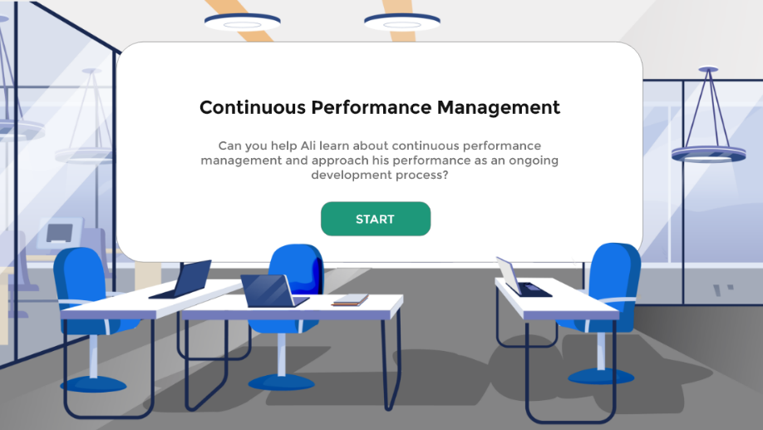
Screen Title: Role Selection
Text/Script | Navigation | On-Screen Graphics
{Banner Title/Heading}  Select your role  {Subheading}  Click on your role below to personalize your experience.  {Button Caption}  Button 1: People Manager  Button 2: Employee | The learner will click on the button according to his/her role. Depending on the button they click, they will have a personalized experience. | 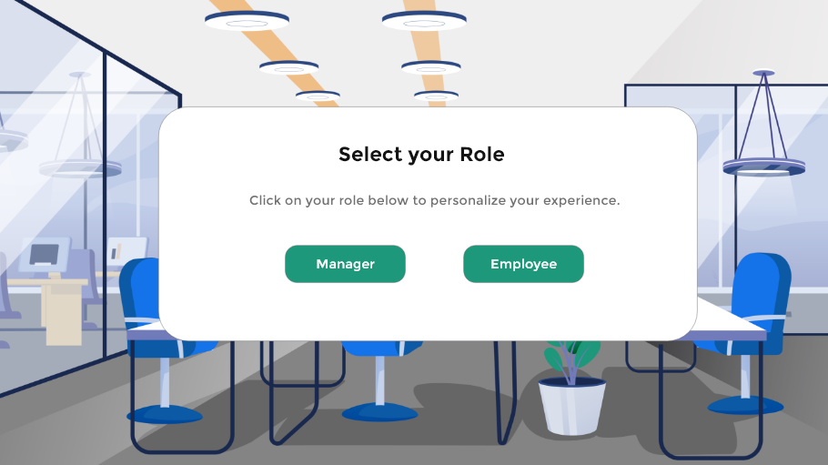
Screen Title: Introduction
Text/Script | Navigation | On-Screen Graphics
Rosmin and Ali are close friends. They spend most of their time together. They have big dreams and plans. When they both received calls to work in the same company, they both were so excited and thrilled to start this journey together. In their first few months at Al-Futtaim, they connected directly with the company and made meaningful relationships. But what they didn’t know was that their experiences will totally change.  At the start of the year, Rosmin and Ali had set ambitious goals for themselves and shared them with their managers. Throughout the year, they both worked tirelessly to achieve their objectives. While Rosmin consistently received recognition from her manager and maintained a clear focus on her goals, Ali struggled to get feedback and recognition for his efforts. As a result, he became demotivated and discouraged.  When it came time for the end-of-year evaluations, Rosmin was well-prepared and confident in her abilities. Ali, on the other hand, had forgotten many of his achievements and activities from the year. Frustrated with his lack of clarity and direction, Ali turned to Rosmin for help. | A video will start directly introducing the story.
Screen Title: Rosmin’s story
Text/Script | Navigation | On-Screen Graphics
Ali had a meeting with Rosmin and asked her about the strategy she follows.  My strategy was so simple. I use continuous performance management concept to keep track of my performance and goals. To support that, we have a tool in iGrow called Continuous Performance or the CPM tool. I use the tool to  - Add the activities that I am working on, and I link them to my goals. I also ensure I mark the activities done as completed or as achievements.  - Request feedback once an activity is done so I can get timely feedback then  - Use the tool to showcase all my activities to my manager when we are undergoing a one-on-one meeting. | Each step will be coming as a separate square with animation. The user will click an arrow to navigate from one step to another. | 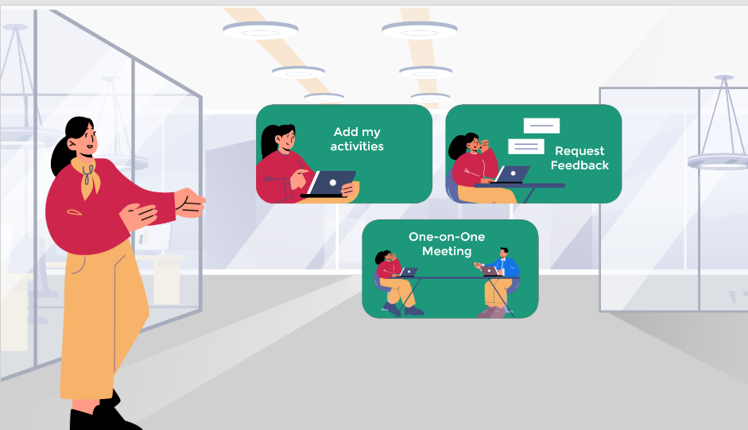
Screen Title: What is continuous performance management?
Text/Script | Navigation | On-Screen Graphics
Annual performance reviews have been the norm in corporations for years. But are performance and development really once-a-year events? Likewise, how useful can feedback be if it’s shared one month—three months—or even eight months after the fact?

That is why Continuous performance management approaches performance as an ongoing development process, rather than an annual appraisal process. It involves giving direct, on-the-spot feedback as well as conducting regular and frequent meetings with your manager to discuss your progress, development, and performance.

Screen Title: Ali’s scenario title slide
Text/Script | Navigation | On-Screen Graphics
{Banner Title/Heading}  Let’s help Ali optimize his performance!  {Subheading}  You will now help Ali use continuous performance management to track his progress towards his goal and make sure he gets the visibility he deserves in the company.  {Button Caption}  Let’s go! | The learner will click on start button to start the scenario.
Screen Title: Question 1 – Remember to Update the CPM
Text/Script | Navigation | On-Screen Graphics
{Banner Title/Heading}  Ali is ready to start!  {Subheading}  Ali is really excited to start using the tool but he is so busy with tasks and projects that he always forgets to update the CPM.  {Multiple Choice Question}  How can we make sure that Ali is consistent with using the tool and keeping track of his activities?  {Multiple Choice Answers}  - Add a reminder on his calendar  - Create a sticky note and add it to his computer (sticky note is gone) – try again  - Add it on his notebook (notebook is lost) – try again  {Feedback for each choice}  - Correct response – this is the best approach. Ali now has set a reminder every end of the month to check the CPM board and update it when needed.  - He added a sticky note and stick it to his desk. However, one day the cleaner came and saw the sticky note on the floor so he threw it.  - He added a note on his notebook. However, given his work, he kept on writing on the notebook and forgot where he initially wrote the note. | The learner will choose one of the choices. He/she will get feedback depending on the answer they choose. | 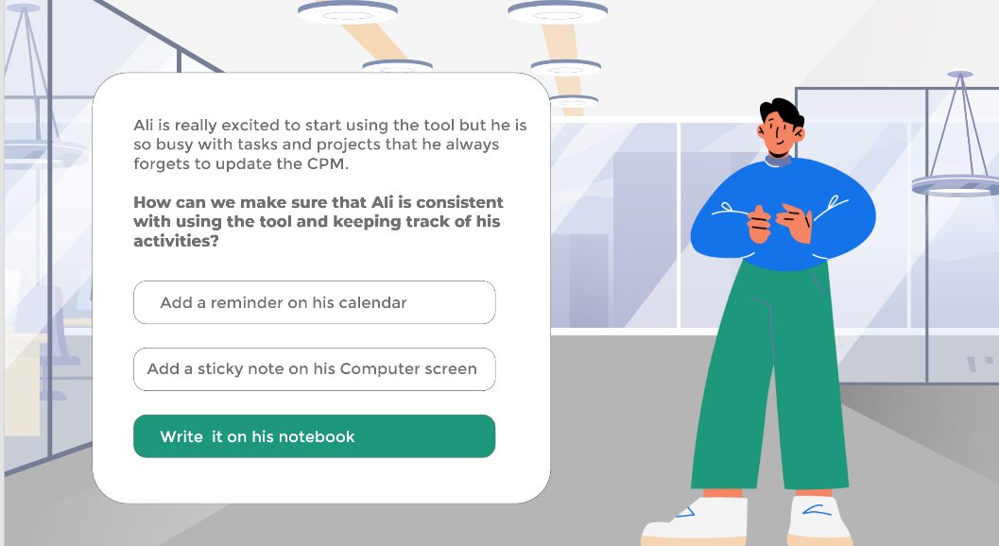
Screen Title: Discover the tool
Text/Script | Navigation | On-Screen Graphics
He added a reminder for end of the week to take the time and familiarize himself with the process. He also has a meeting with his manager, so he wants to be prepared.  Let’s help him to learn more about the tool and how to use it on the system.  {Button Caption}  Discover the tool | When the learner click the button they will get a guided tour of the tool.
Screen Title: Ali’s Goals
Text/Script | Navigation | On-Screen Graphics
At the beginning of the year Ali added his goals on the system:

Business Goals
- Increase the store's sales revenue by 15% by the end of the year.
- Increase customer satisfaction by 10% by the end of the year.
- Achieve 100% assigned monthly and yearly target of 3 million product sales

Developmental Goal
- Enhance his sales techniques skills

Screen Title: Menu Screen
Text/Script | Navigation | On-Screen Graphics
Given Ali’s goals, let’s check how he can use the CPM tool with each of the features below.  - Add Activities & Achievements  - Gather Feedback  - One-on-one Meeting with Manager | The user will click on the first one as the other two will be locked.
Screen Title: What is an activity?
Text/Script | Navigation | On-Screen Graphics
First, let’s make sure we all understand what an “Activity” is. Simply put, activities are the things you are working on. For example, if your goal is running a marathon, your activities might be things like running five miles a day, strength-training… They are personal to you and can be easily linked to one of your performance goals and/or development goals.

{Button Caption}
Continue
Screen Title: Add Activities and Achievements
Text/Script | Navigation | On-Screen Graphics
Choose the activities that Ali needs to put in his system.

Activities examples:
- Write an email sales update to my manager
- Attend training sessions on sales skills
- Achieve 15% of sales target in the first month
- Participate in the trade show to promote the store’s brand and products
- Collect customer feedback using the store form
- Talk to Jane about sales techniques
- Organize the inventory

Feedback:
- Try again – make sure that the CPM tool is not a to do list but rather a high priority view on what you’re currently working on.

- Correct answer! You have selected the correct answer.

Screen Title: Rank Activities Importance
Text/Script | Navigation | On-Screen Graphics
Great! You have helped Ali in choosing which activities to add to the system. What you need to do now is help him sort his activities based on their importance and urgency.  Keep in mind:  High - Really need to get this done as soon as possible  Medium - On my radar, but it could wait a day or two  Low- I’ll get to it when I have time | (Next to each activity we add a dropdown menu where they can choose) Then show the activities in the system as a picture.
Screen Title: Link Activities to Goals
Text/Script | Navigation | On-Screen Graphics
Ali can also link his activities to his performance goals and/or development goals. This is a great way to ensure that he is working on things that are relevant to the goals that he has established whether at the start of the calendar year or anytime throughout the year.  - Attend training sessions on sales skills  Developmental Goal – Enhance Sales Techniques  - Achieve 25% of sales target in the first month  Achieve 100% assigned monthly and yearly target of 3 million product sales  - Participate in the trade show to promote the store’s brand and products  Increase the store's sales revenue by 15% by the end of the year.  - Collect customer feedback using the store form  Increase customer satisfaction by 10% by the end of the year. | Video
Screen Title: Completed Activities and Achievements
Text/Script | Navigation | On-Screen Graphics
Great! Ali has his activities on the system now! With his activities in the system and the reminder on his calendar, he is now able to update his board each month or two to make sure that he is on track and his manager is up to date.  Now, let’s check how Ali can mark the completion of a task.  Once Ali completes a task, he just drags the task to the completed column. He can come back and add activities that he has already completed but forgot to add them in the first place.  Achievements  In many cases, the activities you are working on and complete will constitute a formal milestone or success for your career. So, when you mark any activity complete, the system will automatically prompt you to convert this activity into an achievement. You are not required to convert an activity into an achievement, but the option is there. | Drag & Drop  They can drag the activity and drop it in the completed section
Screen Title: Congratulations
Text/Script | Navigation | On-Screen Graphics
Congratulations! You have added Ali’s activities on the system!
You can collect your badge by clicking on Collect it button.
Screen Title: Menu Screen
Text/Script | Navigation | On-Screen Graphics
Given Ali’s goals, let’s check how he can use the CPM tool with each of the features below.  - Add Activities & Achievements  - Gather Feedback  - One-on-one Meeting with Manager | The user will click on “Gather Feedback” to learn more.
Screen Title: Why Feedback is Important
Text/Script | Navigation | On-Screen Graphics
Do you want to be exceptional at your job? Deliver the best product or service? Add the most value to your team? Continue to grow and advance in your career? Then you need honest feedback from others on your behavior and performance. And to be meaningful, feedback needs to be specific, authentic, and immediate.

With feedback you gain insight into what you’re doing well and areas for improvement. And you can get it at the time it really matters. Receiving regular and direct feedback from managers, subordinates, and peers empowers us to grow as professionals and produce better results.

Feedback Drag and Drop Activity

This:
- Feedback is a learning opportunity
- It challenges me to improve and hone my skills
- It creates a stronger product, service or other results
- It’s exciting! It gives me a way to think about or do things.
- It’s a normal healthy part of any collaborative environement

Not that
It’s not a personal attack on me, my character, or my abilities
It does not mean that the other person dislikes me, is trying to be mean or thinks that I am bad at my job
It’s not uncommon
It’s not the end of the world or a sign of failure
It’s not an excuse to give up, shut down, or stop trying.

{Button Caption}
Continue

Screen Title: Menu Screen
Text/Script | Navigation | On-Screen Graphics
Given Ali’s goals, let’s check how he can use the CPM tool with each of the features below.  - Add Activities & Achievements  - Gather Feedback  - One-on-one Meeting with Manager | After completing the first two sections, the learner will click on the last section.
Screen Title: Ask for Feedback
Text/Script | Navigation | On-Screen Graphics
Let’s now check how Ali can request and gather feedback for his completed tasks and achievements.

Ali achieved 25% of his sales target in the first month. He wants to request feedback from his peers and manager regarding his performance.
However today he is so busy with many things and there are a lot of customers in the store.

What would you advise him to do?
- Wait for tomorrow as he doesn’t have time to deal with this today (He forgets and never had the chance to do it)
- During his lunch break, take 5 mins to request feedback on his performance

He got the below feedback

Manager Feedback:
"Well done on achieving 25% of your sales target in your first month! This is a great start and I appreciate your hard work. As you become more familiar with the sales process, I'm confident that you will be able to increase your success rate. To further increase your success rate, I suggest that you focus on building stronger relationships with potential buyers. This will make it easier for you to close deals and achieve your goals. Keep up the good work!"

Peer Feedback:
I've noticed your dedication and enthusiasm when it comes to meeting your sales targets. You have a great eye for detail and are always looking for ways to improve your performance.

{Button Caption}
Continue

Screen Title: Congratulations
Text/Script | Navigation | On-Screen Graphics
Congratulations! You have helped Ali in requesting feedback from his manager and peers!
You can collect your badge by clicking on Collect it button.
Screen Title: Menu Screen
Text/Script | Navigation | On-Screen Graphics
Given Ali’s goals, let’s check how he can use the CPM tool with each of the features below.  - Add Activities & Achievements  - Gather Feedback  - One-on-one Meeting with Manager | After completing the first two sections, the learner will click on the last section.
Screen Title: Getting the Most Out of One-On-One Meetings with Your Manager
Text/Script | Navigation | On-Screen Graphics
One-on-ones offer an opportunity to get out of the daily grind and think about the big picture items—things like your progress, professional goals, feedback, and job interests or needs. They’re your biggest opportunity to talk about what’s most important to you—and have the undivided attention of your boss.

One-on-ones are unique because the topics covered in the meeting are largely up to you. While your manager will provide structure for the conversation, they’ll be looking to you to help shape and drive it. You determine the direction. Your manager will help you steer by asking questions and bringing up anything else they’d like to add.

That’s why the single greatest thing you can do to maximize your one-on-one time with your manager is to make an agenda or prepare what you’d like to talk about beforehand.

How to use the CPM tool to guide this.

Before your one-on-one meeting:
- Make sure your CPM tool is up to date to show it to your manager and highlight your progress and the challenges that you might be facing along the way
- Create a structure or a flow for the meeting
- Prepare any questions you might need to ask your manager

Screen Title: Congratulations
Text/Script | Navigation | On-Screen Graphics
Congratulations! You have helped Ali in creating a more structured meeting with his manager.
You can collect your badge by clicking on Collect it button.
Screen Title: How Ali’s situation changed
Text/Script | Navigation | On-Screen Graphics
How things changed with Ali
Throughout the year, and with continuously managing his performance through tracking his activities and progress towards his goals, asking and getting feedback, working on the feedback to enhance his performance. Ali feels more focused on his goals and valued in his company. He was getting the feedback and recognition he deserves. In his one-on-one meetings, he is always structured and clear on what he wants to convey in the meeting. When it came time for the end-of-year evaluations, Ali was well-prepared and confident in his abilities.
Screen Title: Video on how continuous performance can help
Text/Script | Navigation | On-Screen Graphics
Video Link:
https://www.youtube.com/watch?v=INXyYn3E47I

Screen Title: System Simulation Introduction
Text/Script | Navigation | On-Screen Graphics
After you’ve been confident in creating all the tasks, asking for feedback and having structured one-on-one meetings with your manager, let’s make sure you are well aware of the system and its navigation.

Depending on the medium you use more, you can try to do the simulation through mobile or desktop.

In the upcoming simulation, we will be adding two activities:
- Achieve 25% of sales target in the first month
- Attend training sessions on sales skills
Screen Title: System Simulation – Add an Activity
Text/Script | Navigation | On-Screen Graphics
• To begin, simply open up iGrow from the Al-Futtaim intranet.
• Click on Home, then click Continuous Performance
Pretty easy right? That’s only the beginning. Let’s now help you understand the different features we offer in the solution.

“ Below steps should be an actual simulation where users will click on each step”

Desktop
- Go to Sucessfactors and click on IGrow
- From the dropdown menu, click on continuous performance
- Click “Create Activity”
- Enter an activity name, status
- High: Really need to get this done as soon as possible
- Medium: On my radar, but it could wait a day or two
- Low: I’ll get to it when I have time
- Paused: Something got in the way and it’s on hold
- Cancelled: No longer happening but want to preserve
- Complete: I did it! Time to celebrate.
- You may choose to link to a performance goal, development goal or both
- Click Save

Click here to know more about how to access SuccessFactors App through mobile.

- Download the Successfator app first
- Go to iGrow page on the intranet
- Click on your profile photo on the home page
- Click on Settings
- Click on Mobile
- Click on Activate via Camera
- Open your Successfator app to scan the QR code

Create an Activity
- Open the SuccessFactors App on your mobile
- Click “Create Activity”
- Enter an activity name, status
- You may choose to link to a performance goal, development goal or both (optional)
- Click Save

Screen Title: System Simulation – Convert an Activity to Achievement
Text/Script | Navigation | On-Screen Graphics
“ Below steps should be an actual simulation where users will click on each step and be able to add text“

Through mobile & Desktop
- Click on the activity
- Click Edit
- Choose status “complete” from the drop down.
- Tick to mark as an achievement
- You may choose to link to a performance goal, development goal or both
- Click Save

Screen Title: System Simulation – Note
Text/Script | Navigation | On-Screen Graphics
We took you through steps on how to add your achievements.
Earlier, you saw what an activity is — Activities are the things you are working on. Achievements in many cases represent the completion of an activity.
But Achievements may also have no relationship to activities, which is perfectly fine. For example, you might have volunteered to do something as part of an initiative around corporate responsibility. Or you might have stepped in at the last minute to close a deal. It might not have been noted as an activity, but it certainly can count as an achievement.

Screen Title: System Simulation – Request Feedback
Text/Script | Navigation | On-Screen Graphics
Below steps should be an actual simulation where users will click on each step”

Desktop
- Click on an activity
- Click on “Request Feedback”
- Enter the name of the person(s) you want to ask feedback from by
– Searching for that name
– Clicking on the name that is auto-populated
- Review the suggested text and customize as desired
- Click “Send”
- Wait for system confirmation and click “Ok”

Mobile
- Open the SuccessFactors App on your mobile
- Click on “More”
- Click on “My Activities”
- Click on an Activity that you want feedback
- Click on 3 dots … at the top right
- Click on Request Feedback
- Enter the name of the person(s) you want to ask feedback from by
– Searching for that name
– Clicking on the name that is auto-populated
- Review the suggested text and customize as desired
- Click “Send”
Screen Title: System Simulation – Feedback Note
Text/Script | Navigation | On-Screen Graphics
Note that you can also Request or Give Ad hoc Feedback. It is not only limited to a specific activity.
Screen Title: System Simulation – Feedback Note
Text/Script | Navigation | On-Screen Graphics
Desktop
Enter the name of the person(s) you want to ask feedback from by
– Searching for that name
– Clicking on the name that is auto-populated
- Review the suggested text and customize as desired
- Click “Send”
- Wait for system confirmation and click “Ok”

Mobile
“ Below steps should be an actual simulation where users will click on each step”
- Open the SuccessFactors App on your mobile
- Click on Request Feedback
- Enter the name of the person(s) you want to ask/give feedback from by
– Searching for that name
– Clicking on the name that is auto-populated

